Unit Name:
Assessment Name:
Tutor/Assessor Name:
Date:
How to use this document…
The reference column is to be used for the assessment question number/AC, or just to label your screenshots.
Paste your screenshot into the screenshot column.
Ensure each screenshot has an annotation to…
- Offer clarity - draw attention to specific elements in a screenshot i.e. what are you showing us?
- Provide emphasis – point out the important parts of the screenshot i.e. showing that you have undertaken something specific.
- Give context – for contextual information that explains the purpose or highlights specific areas.
Reference | Screenshot | Annotation
1.1 | 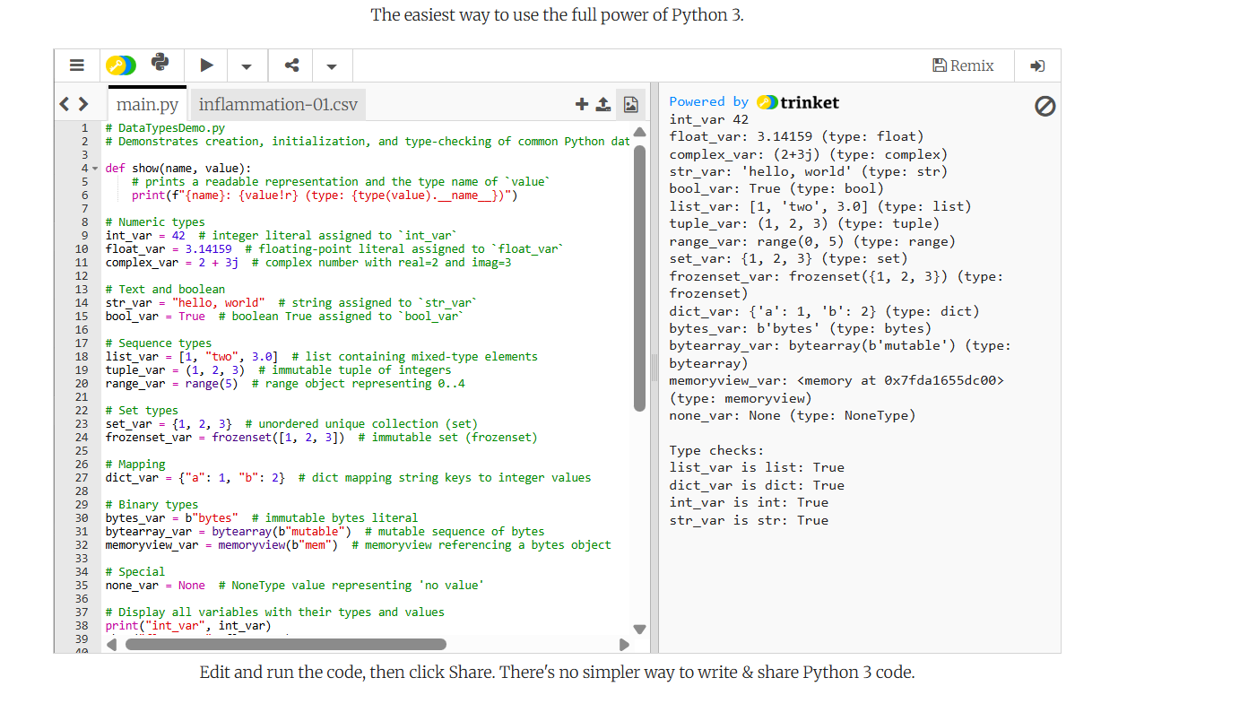 | raw.githubusercontent.com/michael-dgidc/pythoncourse/refs/heads/main/Day2/shoppinglist/DataTypesDemo.py  # DataTypesDemo.py  # Demonstrates creation, initialization, and type-checking of common Python data types.  def show(name, value):  # prints a readable representation and the type name of `value`  print(f"{name}: {value!r} (type: {type(value).__name__})")  # Numeric types  int_var = 42 # integer literal assigned to `int_var`  float_var = 3.14159 # floating-point literal assigned to `float_var`  complex_var = 2 + 3j # complex number with real=2 and imag=3  # Text and boolean  str_var = "hello, world" # string assigned to `str_var`  bool_var = True # boolean True assigned to `bool_var`  # Sequence types  list_var = [1, "two", 3.0] # list containing mixed-type elements  tuple_var = (1, 2, 3) # immutable tuple of integers  range_var = range(5) # range object representing 0..4  # Set types  set_var = {1, 2, 3} # unordered unique collection (set)  frozenset_var = frozenset([1, 2, 3]) # immutable set (frozenset)  # Mapping  dict_var = {"a": 1, "b": 2} # dict mapping string keys to integer values  # Binary types  bytes_var = b"bytes" # immutable bytes literal  bytearray_var = bytearray(b"mutable") # mutable sequence of bytes  memoryview_var = memoryview(b"mem") # memoryview referencing a bytes object  # Special  none_var = None # NoneType value representing 'no value'  # Display all variables with their types and values  show("int_var", int_var)  show("float_var", float_var)  show("complex_var", complex_var)  show("str_var", str_var)  show("bool_var", bool_var)  show("list_var", list_var)  show("tuple_var", tuple_var)  show("range_var", range_var)  show("set_var", set_var)  show("frozenset_var", frozenset_var)  show("dict_var", dict_var)  show("bytes_var", bytes_var)  show("bytearray_var", bytearray_var)  show("memoryview_var", memoryview_var)  show("none_var", none_var)  # Example: check types using isinstance for a few select variables  print() # blank line for readability in output  print("Type checks:")  print("list_var is list:", isinstance(list_var, list)) # True if list_var is a list  print("dict_var is dict:", isinstance(dict_var, dict)) # True if dict_var is a dict  print("int_var is int:", isinstance(int_var, int)) # True if int_var is an int  print("str_var is str:", isinstance(str_var, str)) # True if str_var is a str  # Summary of demonstrations:  # 1. Creation: defined examples for numbers, text, sequences, sets, mappings, binary types, and None.  # 2. Initialization: each variable assigned an idiomatic literal or constructor.  # 3. Inspection: `show()` prints value and its type using `type(...).__name__`.  # 4. Type checks: `isinstance()` used to verify runtime types for common containers.  # 5. Notes: `list` is mutable, `tuple` and `frozenset` are immutable, `bytes` is immutable while `bytearray` is mutable. text desribing thi s example code
 | 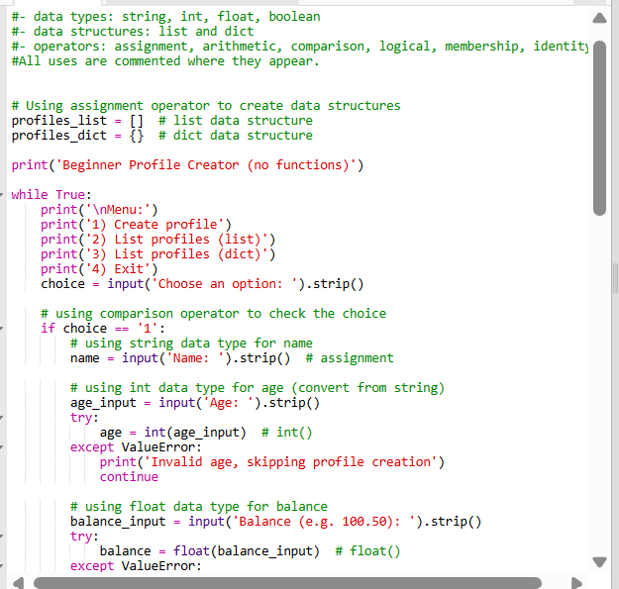 | Variables  ✅ Strings  ✅ Integers  ✅ Floats  ✅ Booleans  ✅ Lists  ✅ Dictionaries  ✅ Input  ✅ Loops  ✅ Conditionals  ✅ Error handling  ✅ Operators  ✅ f-strings  raw.githubusercontent.com/michael-dgidc/pythoncourse/refs/heads/main/Day2/profile_creator_simple.py

